Inspector General
§27-3433 p.26

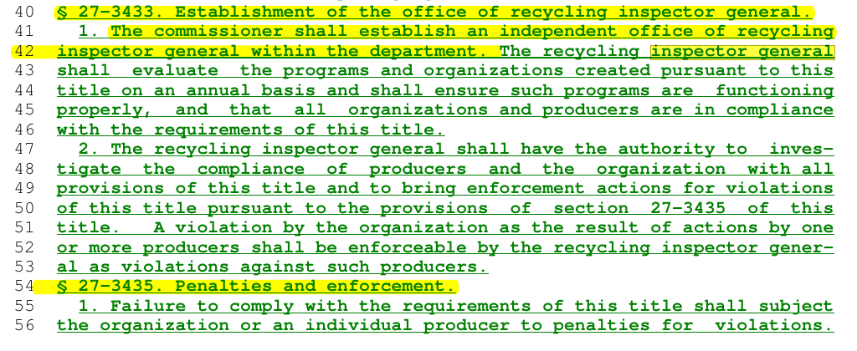
The PRRIA bill does include provisions for an Inspector General—specifically, in § 27-3433 of the bill (PDF p. 26). This new office would be created within the Office of the State Inspector General, with responsibilities to:
- Investigate violations of the act,
- Review complaints from the public,
- Audit producer and PRO activities,
- Issue notices of violation and recommend fines (up to $1,000/day per violation).
How it helps (in theory):
The Inspector General provision is meant to introduce an added layer of oversight and accountability over PRO activities. It's supposed to give the public and the state a mechanism to flag abuses, fraud, or manipulation of data—like greenwashing or underreporting material volumes.
However:
- The Inspector General has no direct power to set or revise or reject PRO plans, set reuse or reduction targets, control funding allocations, prevent exclusion of grassroots and municipal reuse systems, or ensure public oversight of reuse infrastructure - only to investigate and report.
- It does not replace public governance, democratic control, or meaningful statutory requirements.
- It relies on post-hoc enforcement, not proactive program design; it only deals with violations after they happen, and does not prevent them.
- And the IG still exists within a structure where the PRO (producer-controlled) is writing the rules and running the system.
- IG has no independent power to enforce fines. They can only recommend them to DEC and AG.
- Actual enforcement depends on DEC taking administrative actions or the Attorney General pursuing legal remedies. This could mean delays, political hesitation, and inconsistent follow-through.
- If the DEC or Attorney General chooses not to act, the IG’s findings can go unaddressed. There’s no guaranteed accountability—just recommendations and a chain of referrals.
- the IG function is important for visibility but insufficient as a structural check—especially when power still rests with a private PRO.
- The bill does not state how the IG is appointed or what qualifications are required. Unless independently selected and publicly accountable, the IG risks being politically influenced or under-resourced.
So while it’s better than nothing, it does not resolve the core issue: the bill gives private producers and their PRO too much control over system design, funding flows, and priorities—leaving public reuse, local governance, and decentralized solutions under-supported unless they're explicitly mandated.

This Inspector General structure is reactive, not preventative. It can issue penalties after rules are broken (post hoc), but it cannot stop corporate-controlled plans or unfair fund distribution in the first place.
The PRO still holds centralized power over plan design, funding, and priorities — meaning:
- Reuse systems can still be sidelined or underfunded.
- Local governments and nonprofits may be shut out.
- The bill entrenches a structure that puts corporations first — even if an IG occasionally slaps wrists after the fact.

